|  |  |
| --- | --- |
| Project: Redux Tutorial with Redux Toolkit | **Created Date:** 02-02-2022 |

|  |  |
| --- | --- |
| **Project Resources** | |
| *Channel/Creator* | Lama Dev |
| *URL* | https://youtu.be/DYtYyFOfpBY |
| *Github* | https://github.com/safak/youtube/tree/redux |
| *Others* | N/A |



**Project Starts**

**Step1**: Create a react app using windows cli.

* ~~npx create-react-app Myproject~~

**Note**: As you create react app like this way you will get a lot of unnecessary code and file, so instead of doing this you can use github repository template, and you can clone it in your project directory.

To do so you need to go through this link https://github.com/safak/youtube/tree/react-admin and clone it.

Now open your terminal and run some github commands like

* git clone – single-branch -b react-mini <https://github.com/safak/youtube.git> . (please postfix dot at the end)

**Step2**: Now install npm modules in your project.

* npm install

**Step3**: Now go to material ui by using this link https://mui.com/ and install it in your project

* npm install @mui/material

**Step4**: Now add Roboto font in your app inside public/index.html

<link rel="stylesheet" href=<https://fonts.googleapis.com/css?family=Roboto:300,400,500,700&display=swap> />

**Step5**: Now Add Material Ui Icon

* npm install @mui/icons-material or yarn add @mui/icons-material

**Step6**: Now Add Material Ui Custom Style

* npm i @mui/styles or yarn add @mui/styles

**Step6**: Now Add Material Ui Lab

* npm i @mui/lab or yarn add @mui/lab

**Step7**: Now start application

* npm start or yarn start



**Project Code**

My github link



**Project Snapshots**

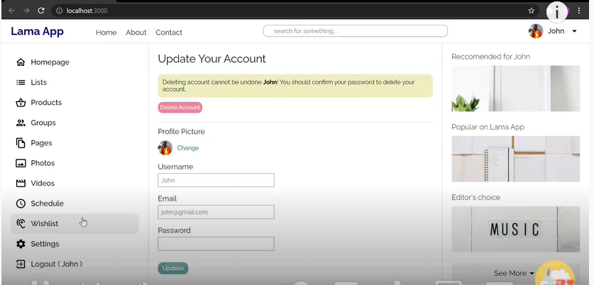

Basics:

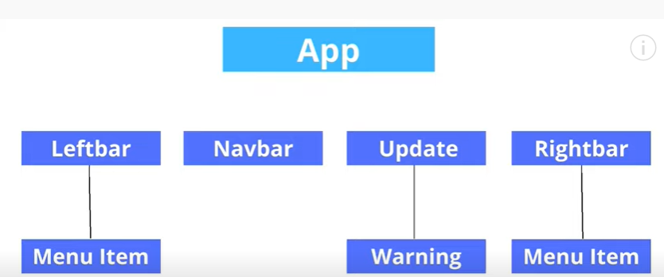

Our main component connect to App and child component are connect to left and right side bars

To update user name at every place

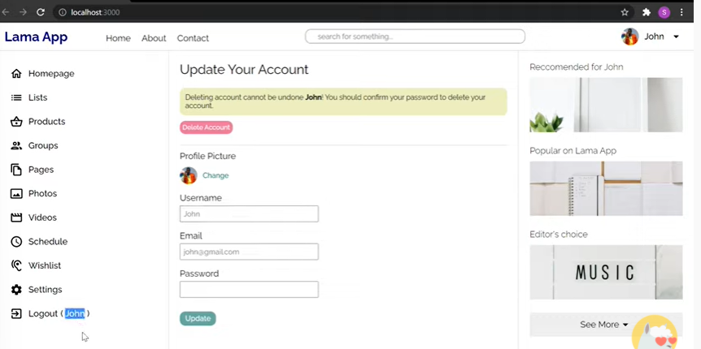

To do this

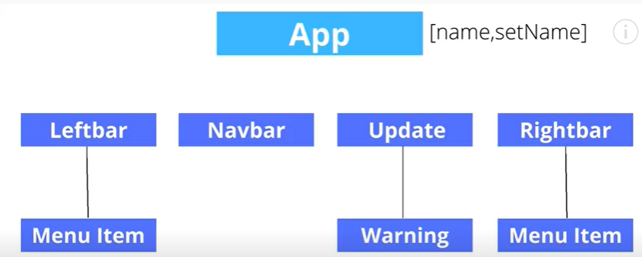

Pass name as a props

As we realized username we are using at many places

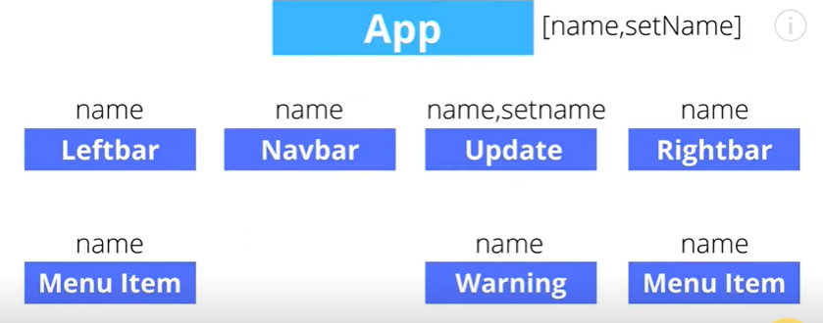

Pass props to whole tree unnecessary all component re-render- its called props drilling

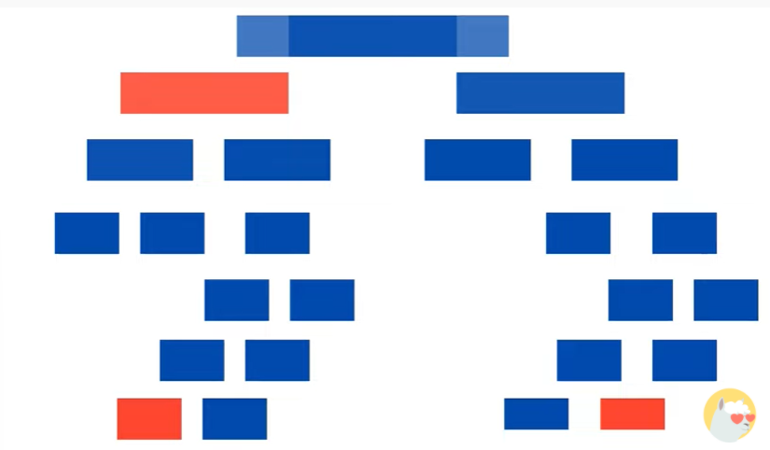

Solution of this problem create a global store

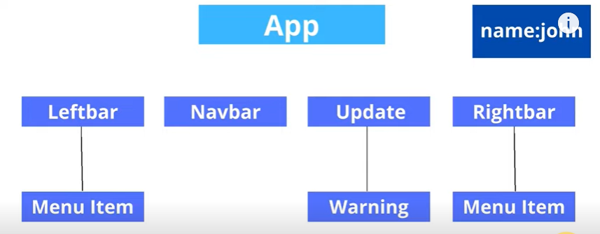

And whenever we need any of these information it provide immediately

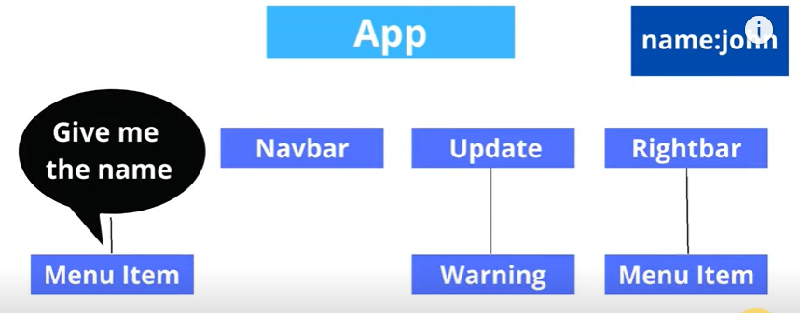

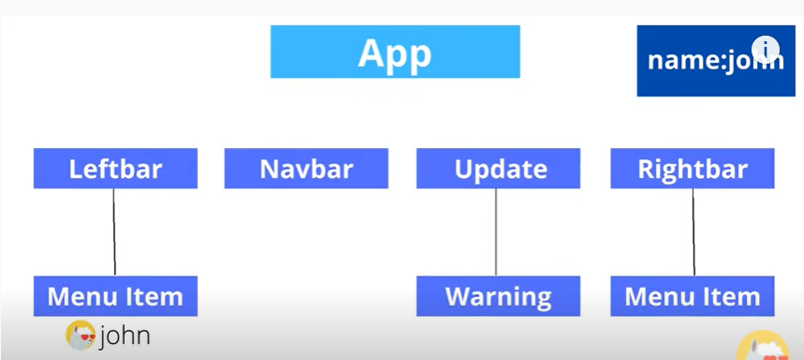

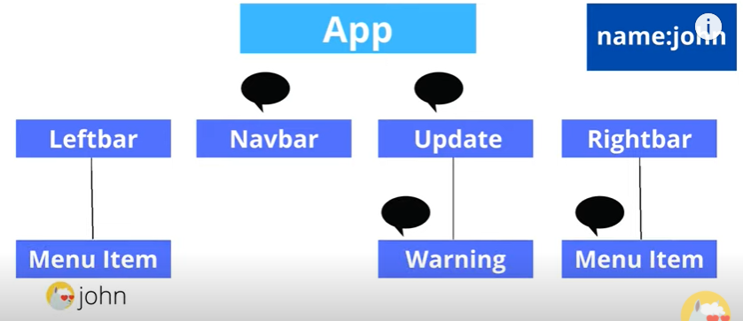

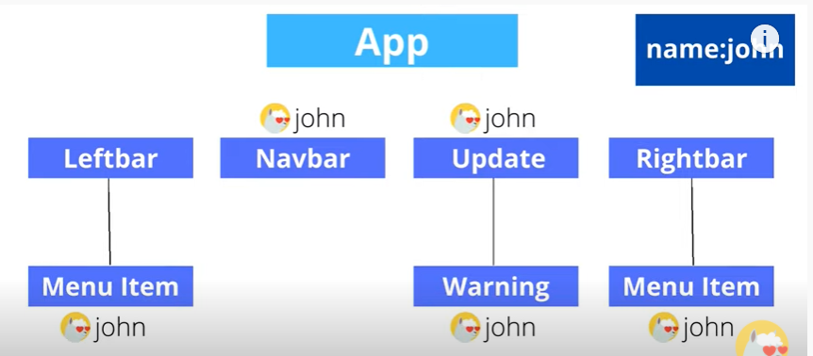

Ab hume sestate use krne ke jarurat nahi ki ab hum component ki state kahi se bhi kabhi bhi change kr skte hai

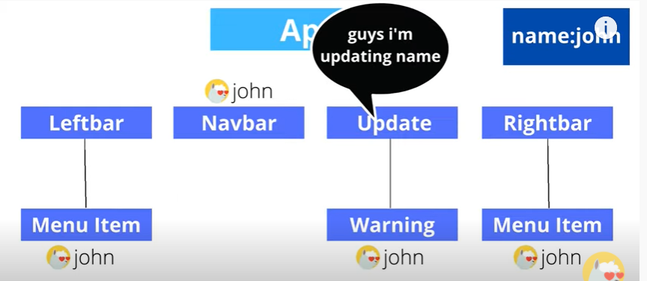

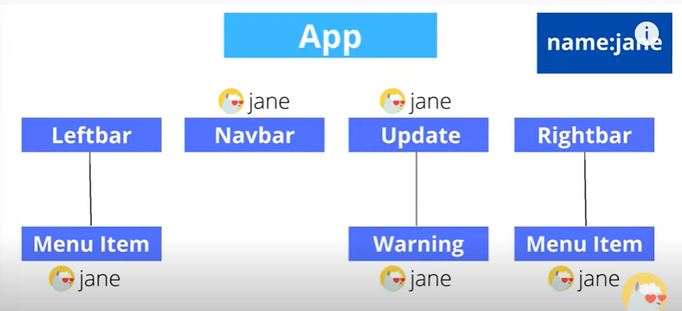

We have have many state management tools but redux one of them.

We also have context API, but context API is not like state management tool, state management kisi eke state ko choose kr skte hai or uske base per component srf ek hi render kr skte hai but context API mein whole state ko chose krna padta hai jiske base per component rendering hti hai

**Compare state management solution?**

Official document

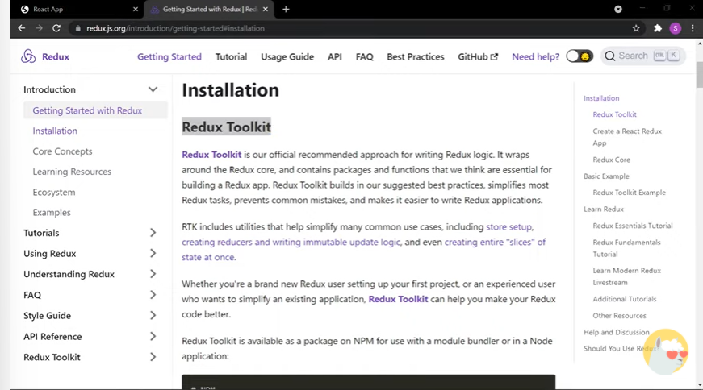

[0:00](https://www.youtube.com/watch?v=DYtYyFOfpBY&t=0s) Introduction

Firstly add redux toolkit

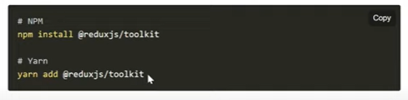

No need of that if already have react app

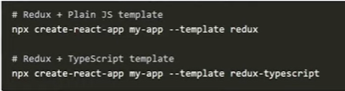

Install core redux

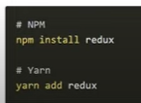

[0:51](https://www.youtube.com/watch?v=DYtYyFOfpBY&t=51s) Why You Should Use Redux

[05:25](https://www.youtube.com/watch?v=DYtYyFOfpBY&t=325s) How to Use React Redux

Firstly, I create Simple React Application with Content and Navbar’s here

[09:41](https://www.youtube.com/watch?v=DYtYyFOfpBY&t=581s)Understanding Redux Reducers and Actions

[14:27](https://www.youtube.com/watch?v=DYtYyFOfpBY&t=867s) Understanding Redux Store

[17:17](https://www.youtube.com/watch?v=DYtYyFOfpBY&t=1037s) How to Use Redux useSelector

[21:10](https://www.youtube.com/watch?v=DYtYyFOfpBY&t=1270s) How to Dispatch Redux Actions

[28:30](https://www.youtube.com/watch?v=DYtYyFOfpBY&t=1710s) Easy Way to Handle Redux Async Actions

[40:48](https://www.youtube.com/watch?v=DYtYyFOfpBY&t=2448s) Redux Async Showing Pending and Error

[45:07](https://www.youtube.com/watch?v=DYtYyFOfpBY&t=2707s) Async Redux with Thunk

[54:27](https://www.youtube.com/watch?v=DYtYyFOfpBY&t=3267s) Outro